**CSE 3215**

**Quiz 3 (Set B1)**

**Time: 20 minutes**

**Marks: 10**

1)

* 1. Derive the formula $-Vout= \frac{Rf}{Rin}(V1+V2+V3…..etc)$ of the Summing Amplifier. (2)
  2. (3)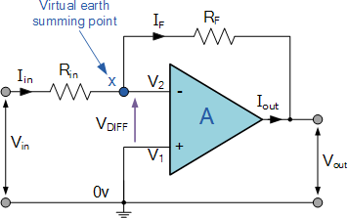

For the above figure, let RF = 100 kΩ, Rin = 10 kΩ and Vin = 1V. Calculate I, Vo and Av.

* 1. A DAC is showing 550V output for the input code 010101. Calculate the LSB and Reference voltage if it operates within 200V to 800V. (2)
  2. What is an Operational Amplifier? Explain with circuit diagram. (3)

Solution:

1(b):

I = 1/10 = 0.1 mA Av=-Rf/Rin = -100/10 = -10

V0 = -Rf/Rin * Vin

=-100/10*1

= -10V

2 (a): Vref = 1676.829 V LSB = 800/2^6 = 12.5